**AWS Task1**

Create a windows Vm machine in AWS and connect with RDP open CMD in windows share the about system info.

Step1: Created a windows VM machine in AWS

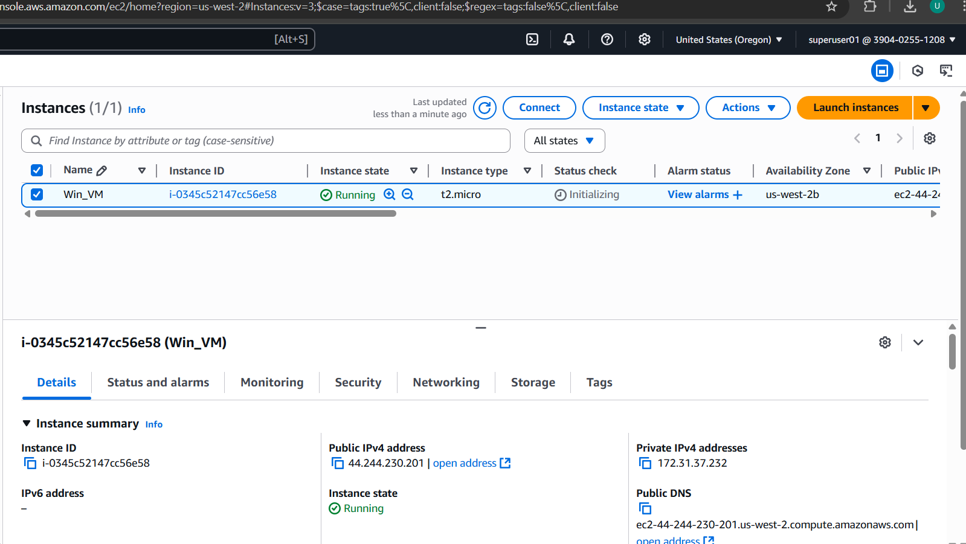

Step2: Retrieved Administrator Password

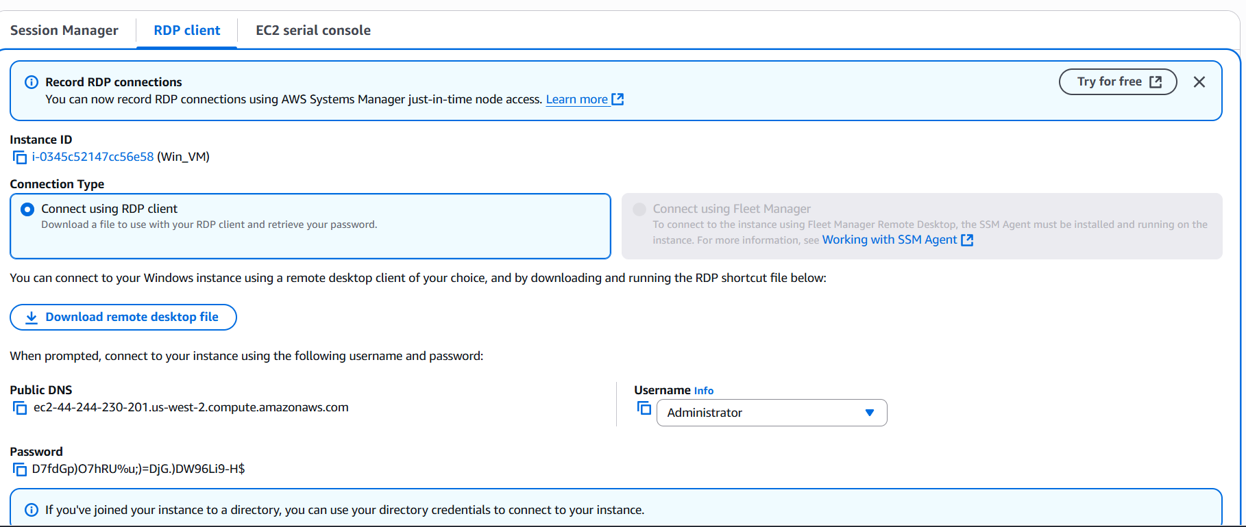

Step3: Connected via RDP

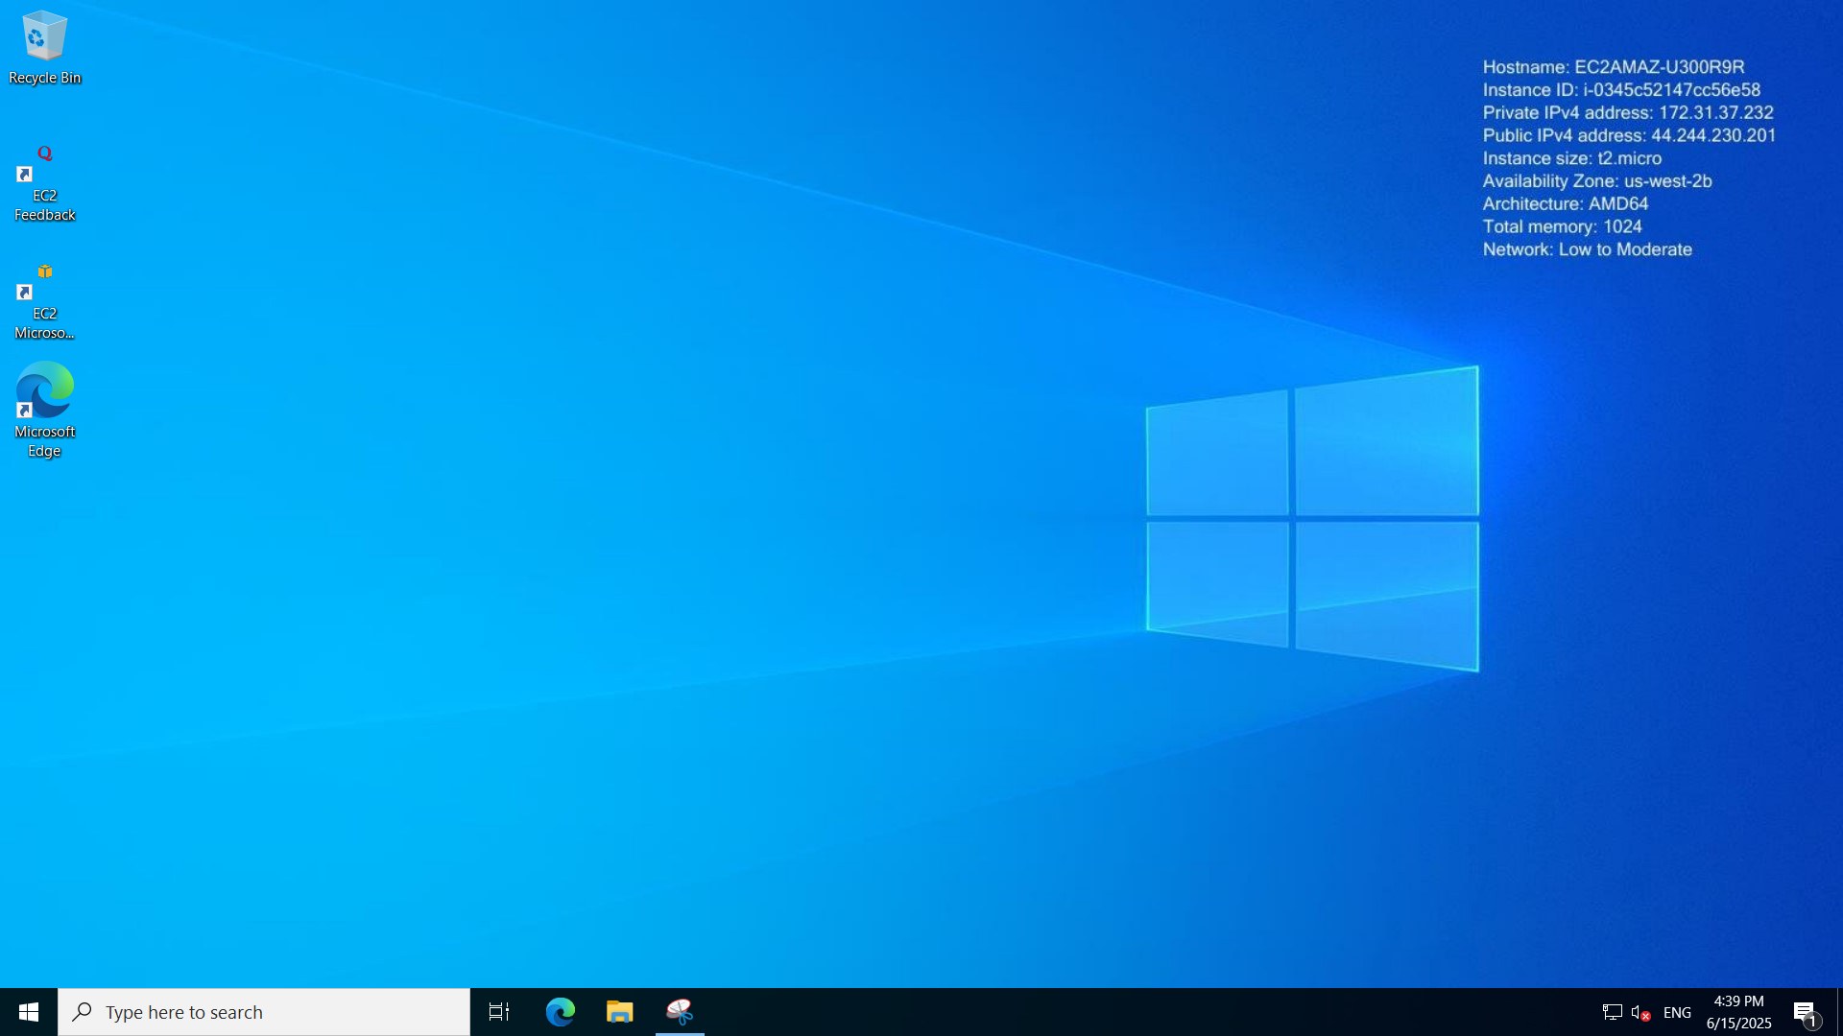

Step4: Retrieved system information

